All You Care to Eat 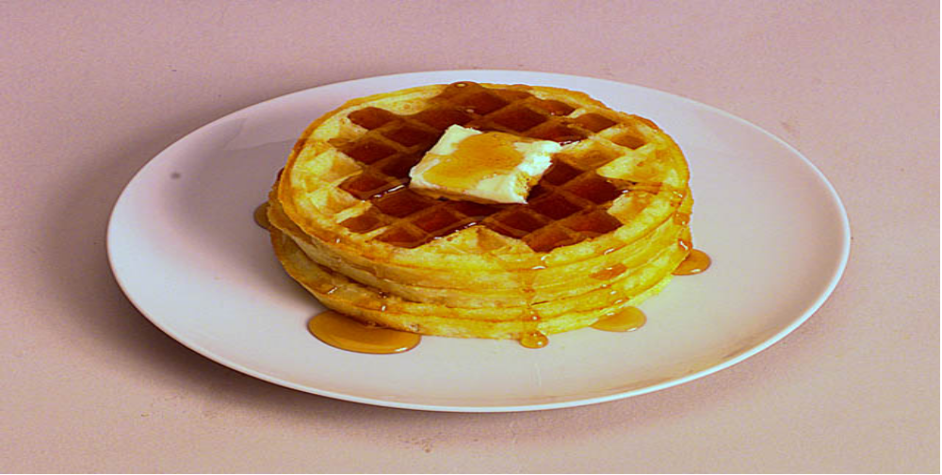

SERVING: WAFFLES, SAUSAGES, TOPPINGS and BEVERAGES

SATURDAY, JULY 10, 2010
8:30- 12:30
DANUBE COMMUNITY CENTER

Sponsored by the
Danube Historical Society

Free Will Donation
CARRY-OUT PLATES AVAILABLE @ $7.00

